Customer purchase behavior analysis

- Project Overview
This project focuses on analyzing customer purchasing behavior using demographic and transactional data. The objective is to identify patterns, trends, and key factors that influence customer buying decisions. The insights derived from this analysis help businesses improve marketing strategies, enhance customer retention, and increase overall sales performance.

- Dataset Summary
The dataset used in this project contains information about customer purchase behavior and transaction details.
It includes approximately 100 rows and 18 columns.
Key Features;
The dataset contains attributes such as Customer ID, Age, Gender, Item Purchased, Category, Purchase Amount, Location, Size, Color, Season, Review Rating, Subscription Status, and Shipping Type.
Both numerical and categorical data are present in the dataset. Numerical data includes Age and Purchase Amount, while categorical data includes Gender, Category, and Location.
Data preprocessing was performed to improve data quality. This includes removing duplicate records, handling missing values, and correcting inconsistent data.
The dataset is used to analyze customer purchasing patterns, identify trends, and generate useful insights for better business decision-making.

- Exploratory Data Analysis (EDA) using Python
We began with data preparation and cleaning in Python:
Data Loading: Imported the dataset using pandas.
Initial Exploration: Used df.info() to check structure and df.describe() for summary statistics.

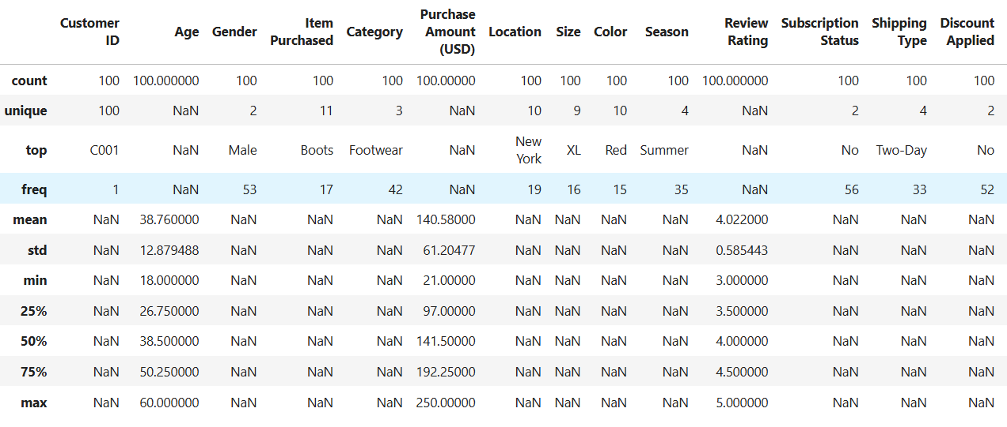
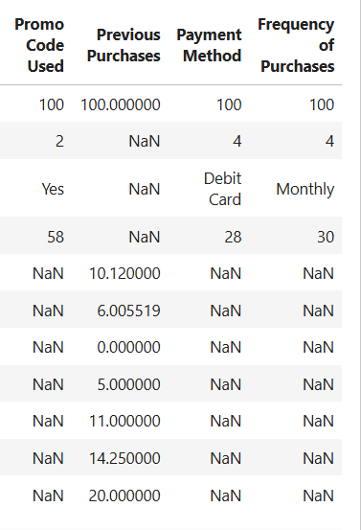

Missing Data Handling: Checked for null values and imputed missing values in the Review Rating column using the median rating of each product category.
Column Standardization: Renamed columns to Snake case for better readability and documentation.
Feature Engineering:
- Created age_group column by binning customer ages.
- Created purchase_frequency_days column from purchase data.
Data Consistency Check: Verified if discount_applied and promo_code_used were redundant; dropped promo_code_used.
Database Integration: Connected Python script to PostgreSQL and loaded the cleaned DataFrame into the database for SQL analysis.
- Data Analysis using SQL
We performed structured analysis in PostgreSQL to answer key business questions.
1.Average Purchase Frequency by Gender – Compared the average purchase frequency of male and female customers to understand differences in buying behavior.

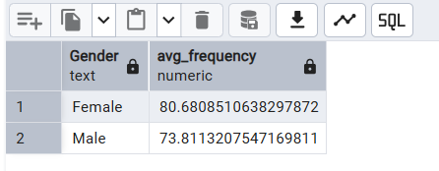

2. Revenue by Age Group – Compared total purchase revenue across different age groups using aggregation functions to identify the highest contributing segment.

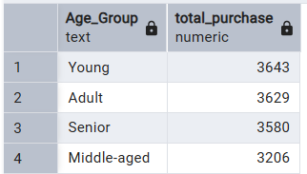

3. High-Value Customers – Identified customers who contribute the highest total purchase value to understand key revenue drivers.

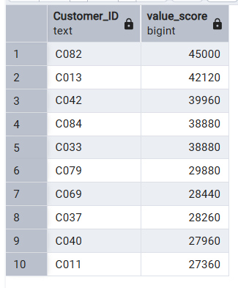
4. Revenue by Category – Compared total revenue generated by each product category to identify the highest-performing segment.

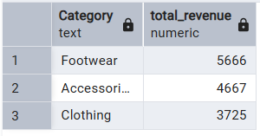

5. Seasonal Purchase Trends – Analyzed total purchase revenue across different seasons to identify variations in customer buying patterns over time.

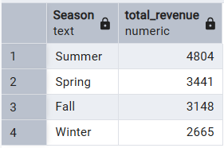

6. Most Popular Size – Examined the frequency of purchases by product size to determine the most preferred option among customers.
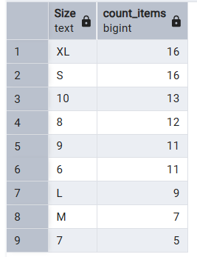
7. Impact of Discounts on Purchase Frequency – Compared average purchase frequency based on discount application to understand its influence on customer behavior.
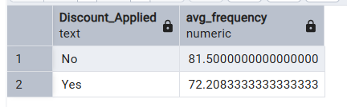

8. Payment Method Analysis – Analyzed average purchase amounts across different payment methods to identify which method is associated with higher spending.
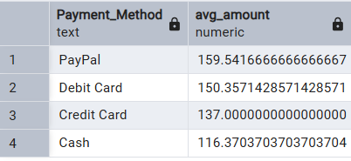

9. Review Rating and Repeat Purchases – Examined the relationship between product ratings and the average number of previous purchases to understand customer satisfaction impact.
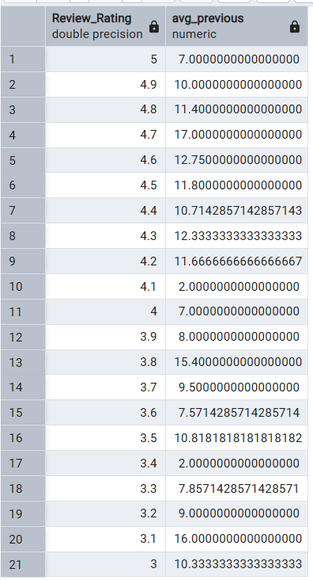
10. Subscription Status and Purchase History – Compared the average number of previous purchases between subscribed and non-subscribed customers to evaluate customer loyalty.

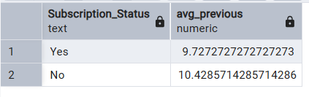

- Dashboard in Power BI
Finally, an interactive dashboard was developed using Power BI to present key insights in a clear and visual manner.
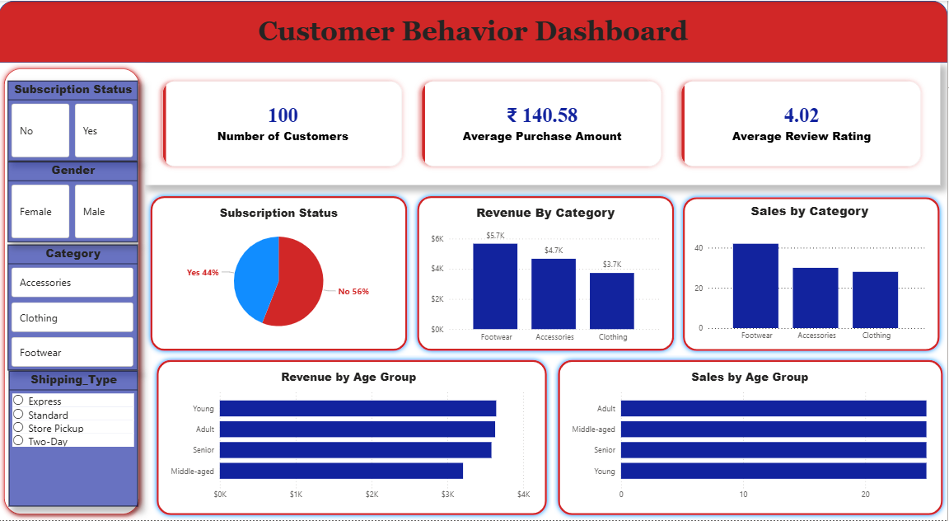

- Business Recommendations
- Focus on High-Value Customers – Identify and retain top customers through loyalty programs and personalized offers.
- Target Key Age Groups – Focus marketing efforts on young and adult customers who generate higher revenue.
- Enhance Customer Engagement – Target female customers with personalized campaigns to increase repeat purchases.
- Optimize Product Categories – Invest more in high-performing categories like Footwear to maximize revenue.
- Leverage Discounts Strategically – Use discounts and promo codes effectively to increase purchase frequency.
- Improve Customer Satisfaction – Maintain high product quality and encourage positive reviews to drive repeat purchases.

